Jeremy Holloway
CPSC-4620-001
6/10/2019

Homework #4

1. Who works on the reorganization project?

SELECT Fname, Lname
FROM EMPLOYEE
WHERE Ssn IN (SELECT Essn
FROM WORKS_ON
WHERE Pno IN (SELECT Pnumber
FROM PROJECT
WHERE Pname = ‘Reorganization’));
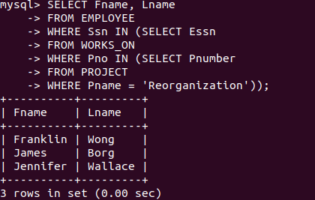

2. Who works on a project that is located in Stafford? Do not show any repeated names.

SELECT DISTINCT Fname, Lname
FROM EMPLOYEE
WHERE Ssn IN (SELECT Essn
FROM WORKS_ON
WHERE Pno IN (SELECT Pnumber
FROM PROJECT
WHERE Plocation = ‘Stafford’));

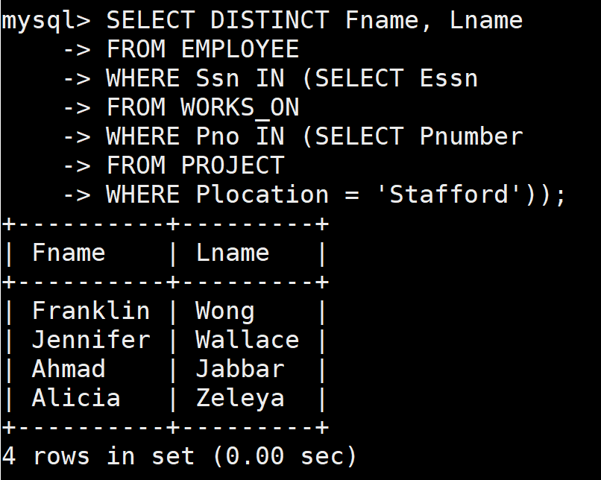

3. Which employees have a daughter, and what is that daughter’s name?

SELECT Fname, Lname, Dependent_name
FROM (DEPENDENT JOIN EMPLOYEE ON Essn = Ssn)
WHERE Relationship = ‘Daughter’;

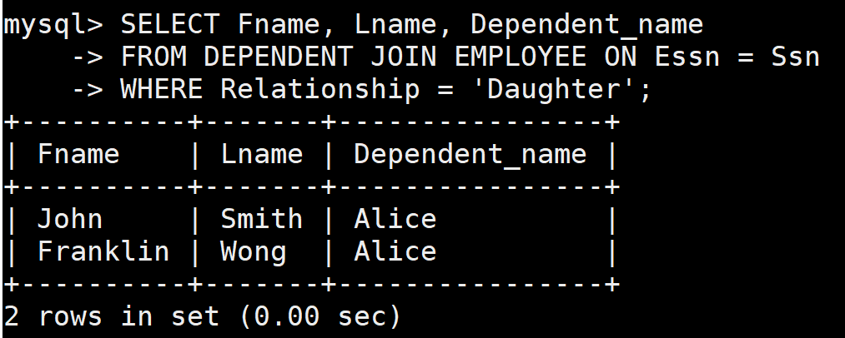

4. Tell me the names and addresses of all the managers, as wells as the number of dependents they have (even if they have zero dependents).

SELECT Fname, Lname, Address, COUNT(Dependent_name) AS Dependents_no
FROM (EMPLOYEE JOIN DEPARTMENT ON Ssn = Mgr_ssn) LEFT OUTER JOIN DEPENDENT ON Ssn = Essn
GROUP BY Fname;

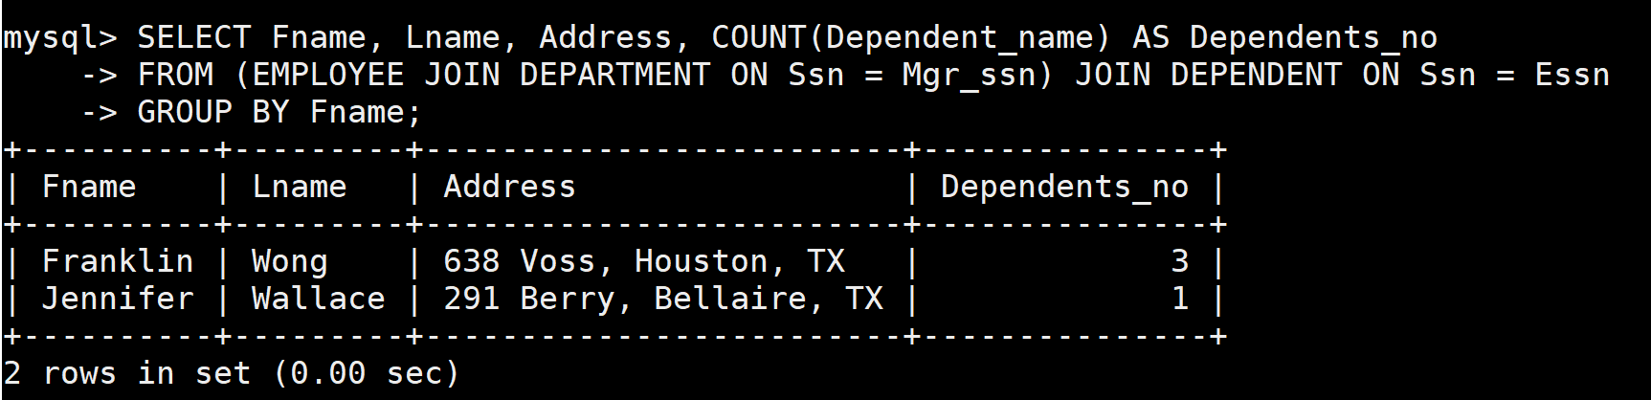
5. Show me the names of all employees who have a supervisor.

SELECT Fname, Lname
FROM EMPLOYEE
WHERE Super_ssn = ANY (SELECT Ssn
FROM EMPLOYEE );

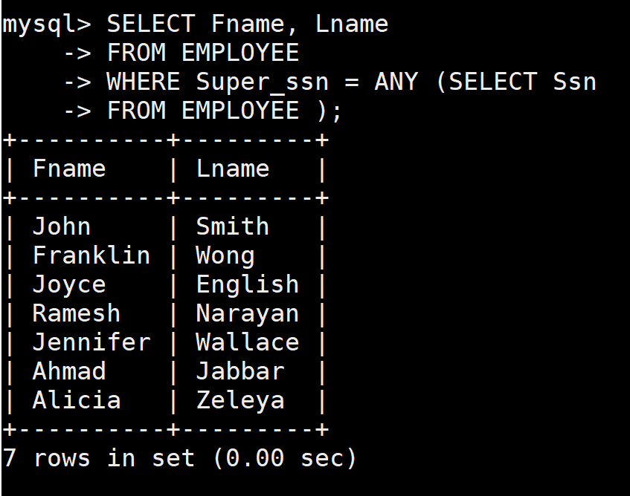

6. What are the names of all employees who work in the Administration department who make less money than at least one employee who works in the Research department?
SELECT Fname, Lname
FROM EMPLOYEE
WHERE Dno IN (SELECT Dnumber
FROM DEPARTMENT
WHERE Dname = ‘Administration’)
AND Salary < ANY (SELECT Salary
FROM EMPLOYEE
WHERE Dno IN (SELECT Dnumber
FROM DEPARTMENT
WHERE Dname = ‘Research’) );
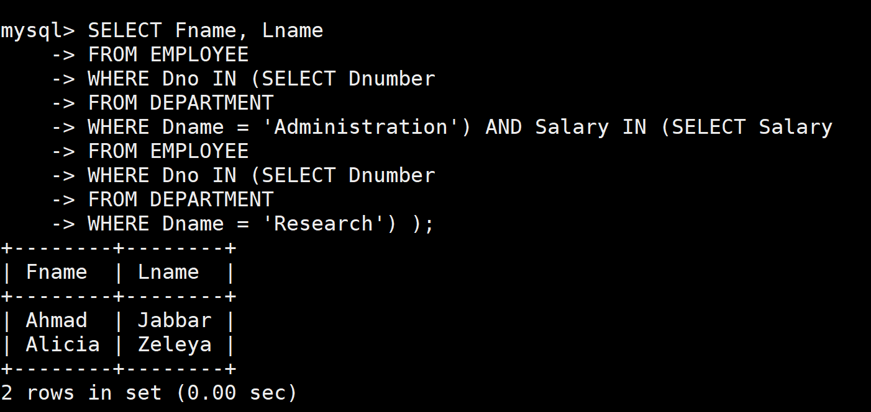
7. For each Project, show the project name, the number of employees who work on the project, and the average hours per week each employee works on the project. Order the results alphabetically by the name of the project. A project could have 0 employees working on it.

SELECT Pname, COUNT(Essn) AS Employee_No, AVG(Hours) AS Avg_Hours
FROM PROJECT JOIN WORKS_ON ON Pnumber = Pno
GROUP BY Pname
ORDER BY ASC;
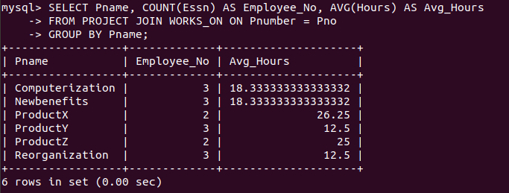
8. For each employee, show the number of projects they work on. They could work on 0 projects.

SELECT Fname, Lname, COUNT(Hours) AS Project_no
FROM EMPLOYEE LEFT OUTER JOIN ON WORKS_ON ON Ssn = Essn
GROUP BY Fname;

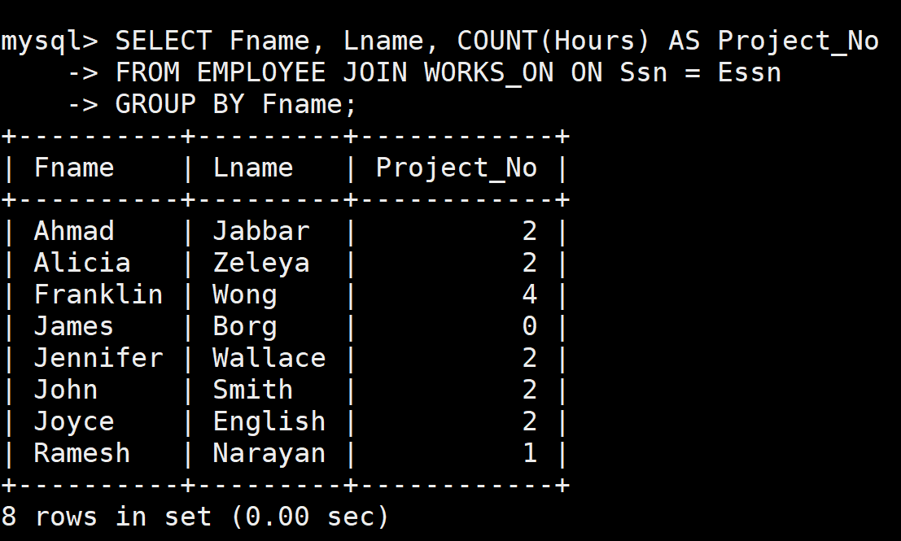

9. Show the names of all dependents who are dependents of someone who works on the reorganization project.

SELECT Dependent_name
FROM (DEPENDENT AS D JOIN WORKS_ON AS W ON D.Essn = W.Essn) JOIN PROJECT ON Pno = Pnumber
WHERE Pname = ‘Reorganization’;

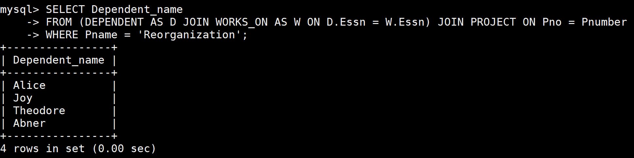

10. For employees who make less than $30000, change their salary to $30000. For all other employees, give them a 10% raise. (This should be done in ONE SQL command)

UPDATE EMPLOYEE
SET Salary =
CASE WHEN Salary < 30000 THEN Salary = 30000
WHEN Salary >= 30000 THEN Salary = Salary * 1.1;

